REST API

1.Why do we need REST API?
Consider a scenario that ur using BookMyShow APP in a Regular Basis. When ur using this app if u observ app needs a lot of input data and what ever data present in app is never standard one.
When u consider book my show app every time movies and movie timing can change it means input data of a app needs to be changed or updated on a regular basis. So where do you this this data came from well this data is received from a server most commonly known as a webserver.
So the client requests to server for a required information via API and then server sends back a response to the client over here the response send to a client is in the form of HTML page.
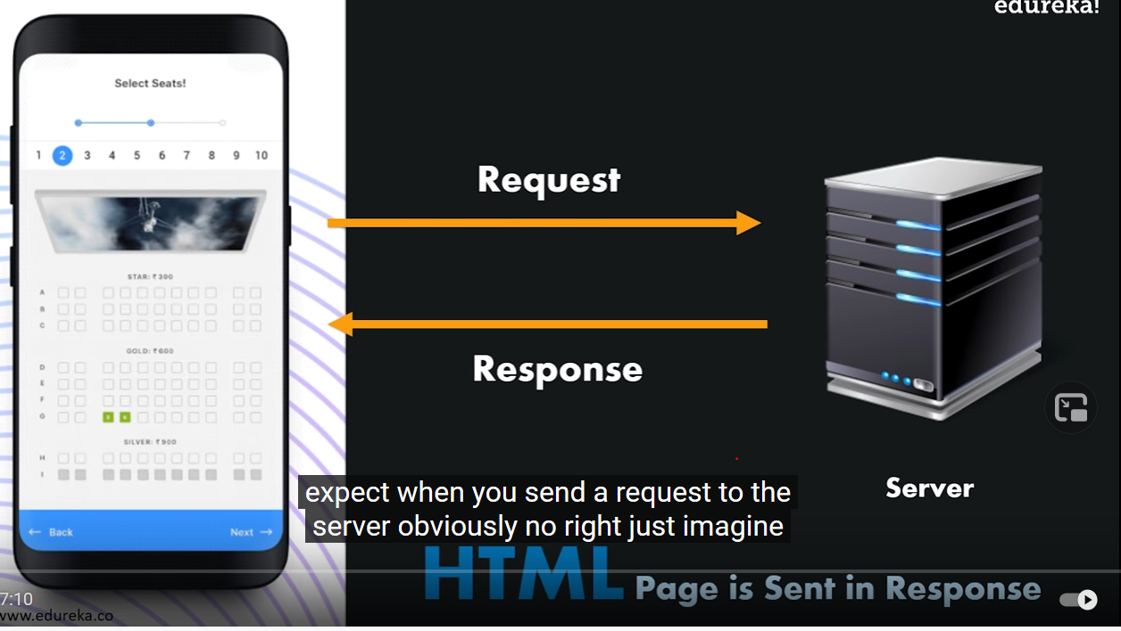
Note: APP wont responds to HTML Pages app no need of gui app needs only data
So now the expectation is app needs a data from webserver with proper structure and format.
Data should be in a form of JSON or XML format. Because these have a proper structure and format
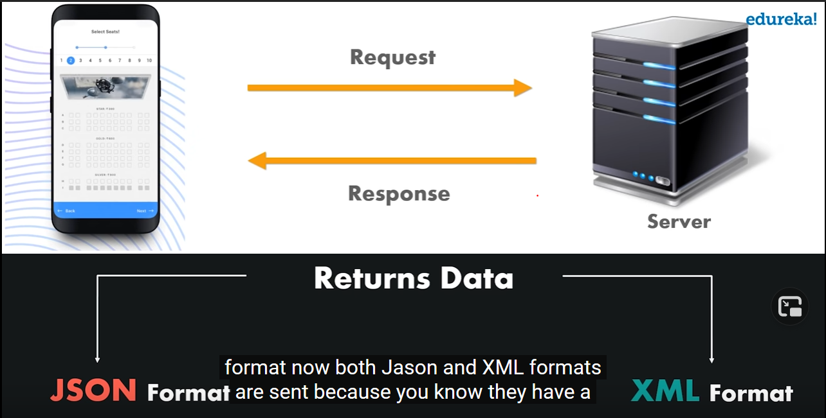
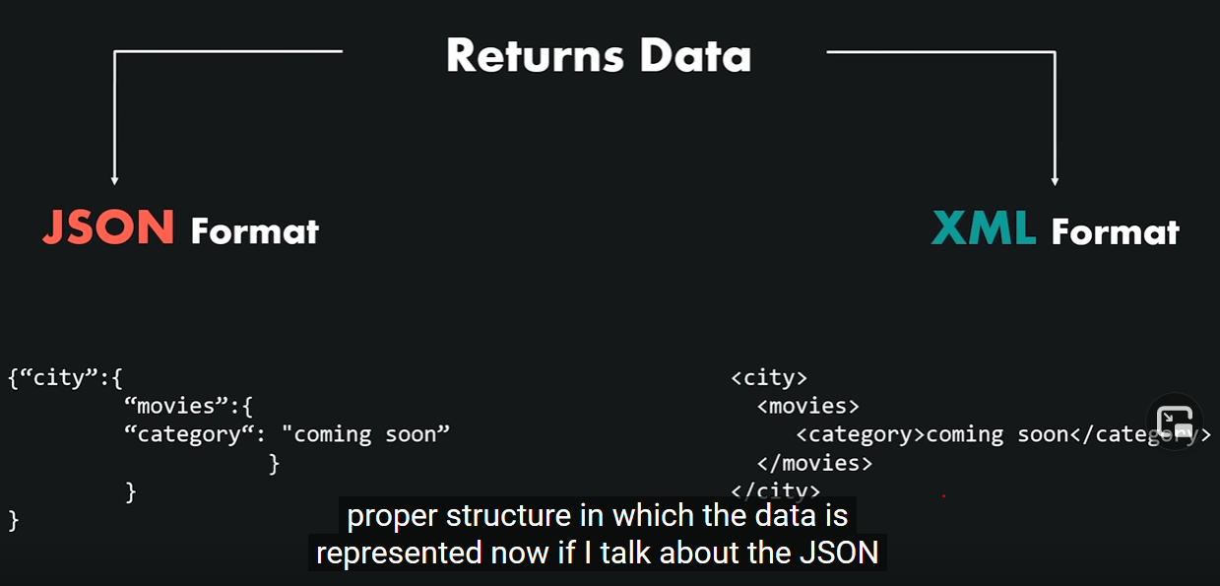
To get the data from webserver using REST API u have to use a lot of methods.

2. What is REST API??

Create an object on the server side and return the values of an object. Representational State Transfer.
You can just create an object of the data requested by an client and sends the values of an object to user.
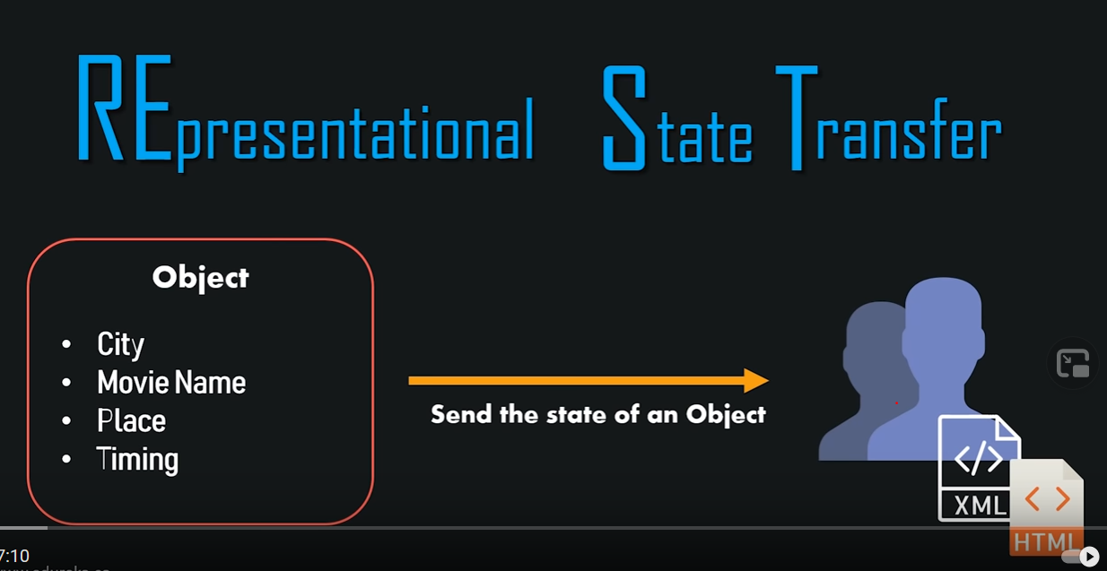
Example: lets take a specific movie senario for bookmyshowapp
Infinity war movie is playing at imax hyderabad timing 9:30 pm.
Now if u want to find out particular data like above. For this now client will send a request to the server
When request is sent to webserver what rest API does is it creates an object of an particular request and then it finds out whether data available or not if it finds out that the data is present then it sends back a response to the client values of particular object requested by client.
Its just passing an state of object to client.
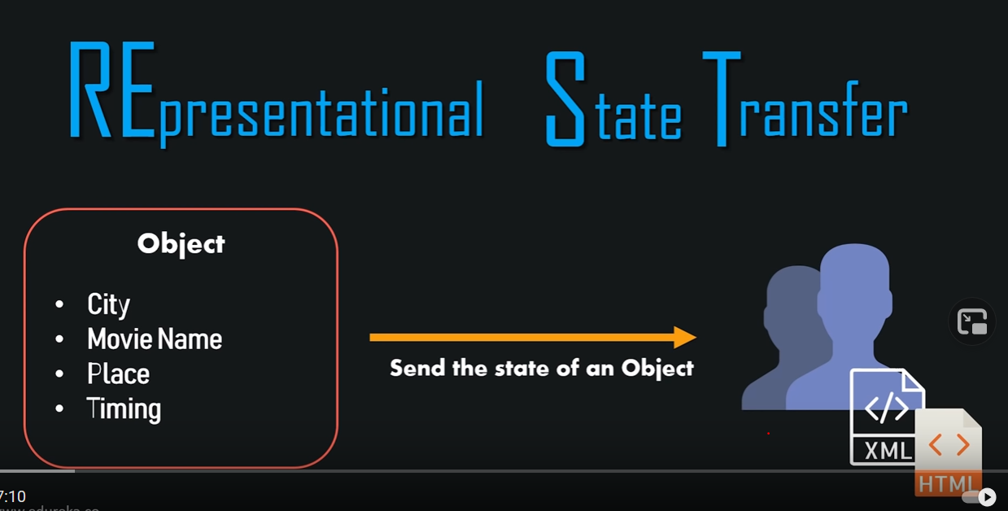
- Its an architectural style as well as an approach for communications purpose that is often used in various web services development.
- it is often regarded as the “ Language of the Internet”
- it is a stateless client and server model.

3.Features of REST API:
-similar than SOAP
-proper Documentation
-Proper ERROR Messages.

4.Principles of REST API:

-Stateless
When a request sent by an server it contains all the info that makes server understandable
-Client Server
-Uniform Interface
-Cacheable
-Layered System
-Code on Demand

5.Methos of REST API:

We are working on web technologies. We crud apps: create,read,update,delete resource.
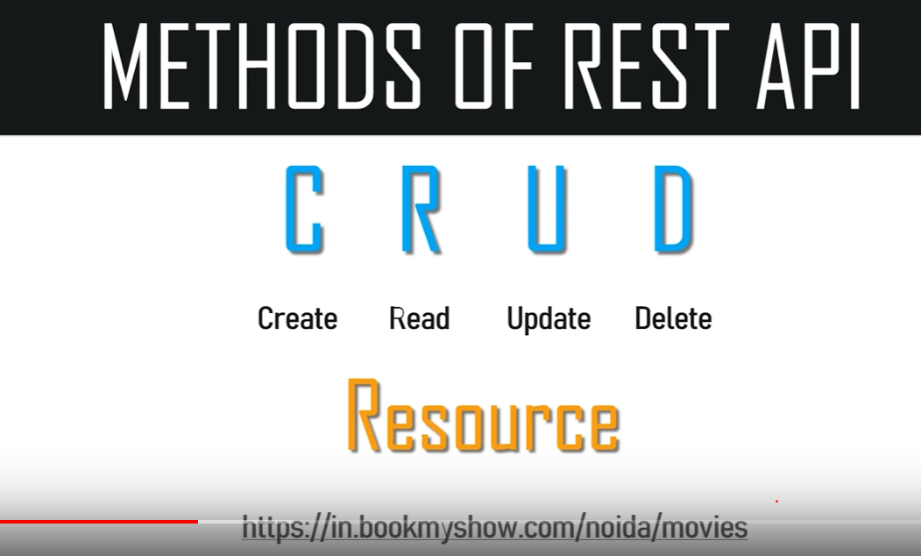
Resource is a client requirements.
To do all above CRUD activities we can use the methos of API REST

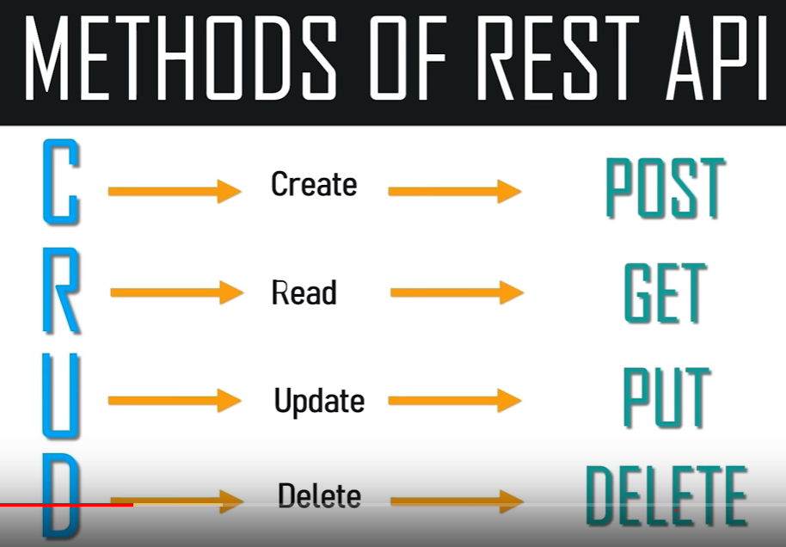
Craeting resource : Create-------POST
Reading resource: Read----------GET
Updating resource: Update------PUT
Deleting resource: Delete-------Delete
All these methods are HTTP Methods:
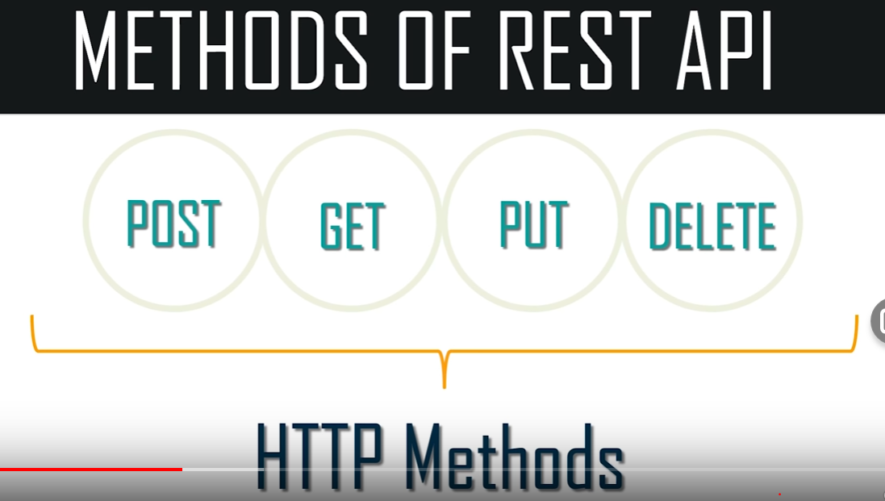

6.How to TEST REST API:

To Test REST API we will use postman Application its just an webclient it will send requests to the servers.
Find url to check from postman app like below:
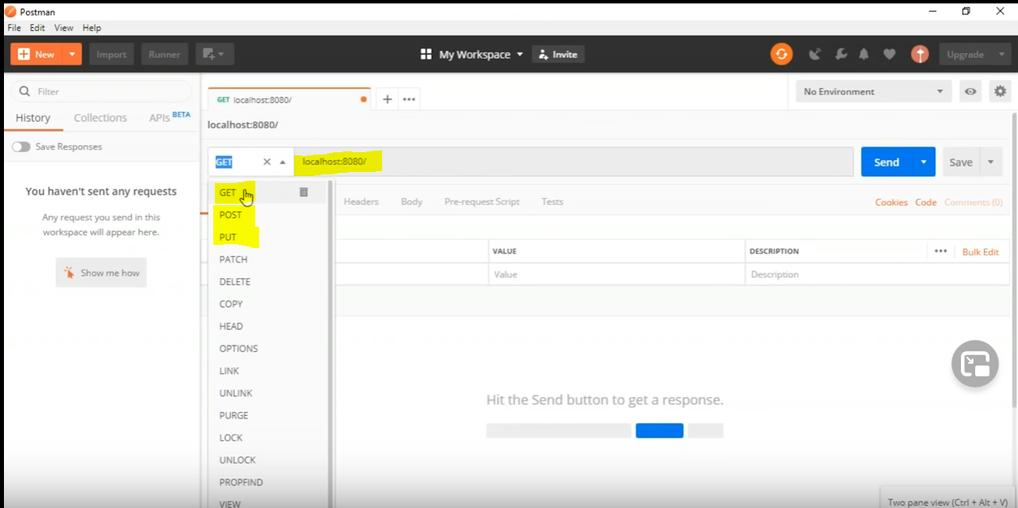
And click on send u will get rply like below:
